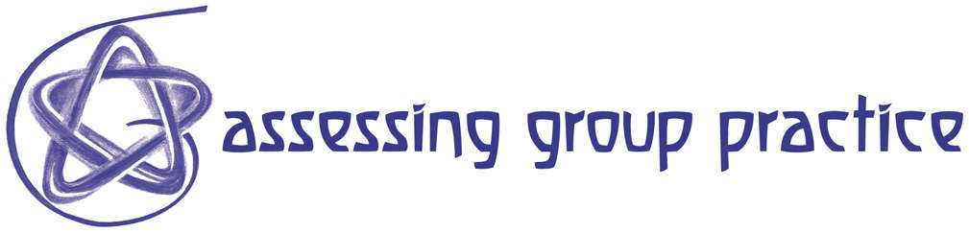

R 23 How to Use Peer Feedback to Assess Process and Product

This approach to the presentation of project work is intended to be recognised as part of a number of learning processes and to form no more than an initial input into assessment. This particular version, developed with first year Performance Writer, is easily adaptable for other practices and for later stages in the learning processes.

Behind it are the following assumptions:
- Although it is very important that students can talk intelligently and persuasively about their own work, this should not be confused with how the work itself speaks
- Assessment processes should ensure that both can be assessed in ways that clarifies the difference between them
- Students can build critical attention and articulacy by taking responsibility for presenting the work of others
- A rush to judgement is not helpful within learning; hence the emphasis in the following process on identification and interpretations of qualities in work and an embargo on unsupported value words

A method

It is the end of a project or of a phase of a project. Work has been produced by individual students.
- Divide the group into pairs and charge each member of the pair to give close witness to the work produced by the other, without asking any questions of the author.
- Everyone in the group then presents the work of their pair-partner to the whole group under the following (or similar) headings:
  - What do you see/hear?
  - What does it say to you?
  - What does it do?
- Each presentation is followed by brief group discussion – usually led by a tutor; the author/maker should usually remain silent during this (unless the tutor feels that a matter of information is required); at this stage there should be no statement of intention
- (Optional) The author/maker responds briefly.

When this works well the author/maker receives invaluable feedback about how some others see the work. The presenter learns from applying close attention to work, from articulating this attention into words, from taking responsibility for constructive feedback.

I have not used this approach within collaborative projects but feel it could be adapted to get around special pleading when arriving at views of contributions within collaboration.

John Hall
10.06.02

